User Guide for the MODIS Vegetation Continuous Fields product Collection 6, version 1

PI: John Townshend
Co-I: Matthew Hansen
Co-I: Mark Carroll
Co-I: Charlene DiMiceli
Co-I: Robert Sohlberg
Co-I: Chengquan Huang
University of Maryland

Table of Contents
User Guide for the MODIS Vegetation Continuous Fields product Collection 5 version 1 1
1. Table of Contents 2
2. Introduction 3
3. Algorithm 4
3.1. Training Data 4
3.2. Data Inputs 5
3.3. Data Algorithm 5
4. Data Layers 5
4.1. Percent_tree_cover 6
4.2. Quality 6
4.3. Percent_tree_cover_SD 6
4.4. Cloud 6
5. Results 7
6. Validation 9
7. Accessing and citing the data 9
8. References 10

Introduction
Characterization of the land surface from satellite data has been performed for over three decades. The Vegetation Continuous Fields (VCF) product is a global representation of the Earth’s surface as gradations of three components of ground cover: percent tree cover, percent non-tree vegetation and percent bare (figure 1) (Carroll et al, 2011; Hansen et al. 2000,2002,2003,2005). Each pixel is shown as a sub-pixel mixture of cover with each of the three components expressed as a percentage of ground cover.
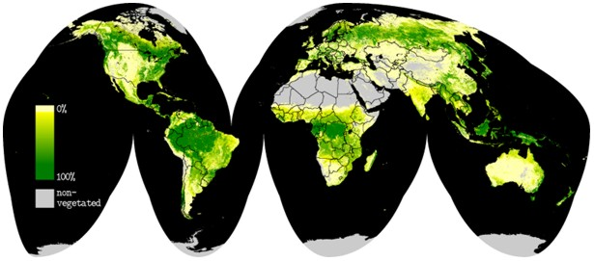
Figure 1. Global Vegetation Continuous Fields percent tree cover for 2001. Darker greens indicate denser tree cover, pale colors indicate light tree cover, and gray indicates no tree cover.

The three components are stored in separate layers so they can be used independently to look at a particular type of ground cover or collectively to look at the entire surface.
When originally proposed the VCF product represented a revolutionary new approach to the characterization of vegetative land cover (DeFries and Townshend, 1994; DeFries et al, 1997). Conventional land cover classifications suffer from the imposition of arbitrary thresholds between classes, and the characterization of the land surface is highly dependent on the a priori class boundaries which are chosen (Hansen et al, 2002). Moreover when land cover products are used in models, parameterization has to be carried out, which is often crude and inaccurate. By depicting each pixel as a proportion of characteristics such as percentage tree cover, non-tree vegetation cover and bare ground a genuinely quantitative depiction of land cover is possible. The advantages of this approach have been recognized by the widespread adoption of the VCF product by many users in the modeling and monitoring communities. The VCF product has also been identified as an Earth System Data Record (ESDR) by the science community (Masek et al, 2006).
Historically the creation of the algorithms for the production of global land cover maps was largely hand crafted, as human intervention was required to help the algorithm make distinctions between certain land cover types, such as distinguishing wetlands from forest. The current version of the VCF algorithm endeavors to minimize the human element and automate the algorithm. The early MODIS VCF algorithms were developed using a semi-automated process where regression tree models were created using machine learning software. These trees were then evaluated by an operator, who might add training at certain branches of the tree or simply eliminate parts of that tree. This human interaction was necessary because the training data, though very good at the time it was created, had some inconsistencies. In the new approach, the training data has been completely updated using Landsat Geocover data and has been revised and refined using the plethora of fine and ultra-fine resolution data available through the NASA science data purchase and Google Earth, among many others. The improved training data and the implementation of new and improved data mining software have resulted in much greater accuracy in the final product without human intervention.
The final algorithm for VCF operates in a completely automated fashion with the results published upon completion. The following pages describe in detail how this algorithm came to be and basically how it works.

Algorithm
The first step in the process was to develop an updated training data set. The spatial resolution for MODIS data used in the VCF Collection 6 product is 250m. The training data that were used for previous versions of the VCF product were developed in the late 1990’s and revised circa 2001. This data set represented a high quality data set at the time, but relied heavily on Landsat 5 Thematic Mapper data from the 1980’s. With the availability of the ortho-rectified Landsat Geocover and globally available fine resolution data, it was advantageous to create a completely new training data set that better matched the acquisition dates of the MODIS data (2000 to present).

Training Data
Training data were created by performing a discrete classification on the Landsat data into 4 classes of relative percent tree cover (0, 25, 50, 80+). These relative percentages were verified by overlaying the scenes with fine and ultra-fine resolution imagery from Ikonos, Quickbird, and other data as available. In addition, comparisons were made to Google Earth where tree crowns can be seen distinctly. Adjustments were made to the discrete values as necessary to match observed conditions from the fine resolution data. The 30m data were then averaged to 250m spatial resolution yielding a continuous representation of the surface for that scene from 0 – 100 percent.
As specific areas are identified where training data is insufficient, training data has been augmented with new information. An example is the recently added training in the far north where low light during the winter creates unique conditions.

Data Inputs
The inputs for the MODIS VCF product are 16-day surface reflectance composites which include MODIS bands 1 – 7 and brightness temperature from MODIS bands 20, 31, and 32; the training data (described above); and the MODIS Global 250m Land/Water Map. The surface reflectance composites that are used are an intermediate product generated inside the MODAPS production facility for the VCF product (for further information see Carroll et al. 2011). There are 23 16-day composites for each year of data. One year of 16-day composites is further composited to yield 8 composites per year in order to minimize clouds and as a data reduction step. These 8 final composites are used in the data production algorithm.

Data Algorithm
The production algorithm for VCF runs in three parts: sampling inputs under the training data; creating models; and applying the models to the output. These three steps are accomplished with open-source software (Weka data mining software) called by custom software written in C programming language that handles I/O and metrics creation. Weka was chosen because it is flexible, robust, open source and capable of handling large data sets. The production software is being run in the MODIS Adaptive Processing System (MODAPS).
In the first step, the algorithm creates 30 randomly-selected samples from the composites and training data set, and calculates metrics, creating inputs for model building. Model creation, the second step is performed by the Weka data mining software, is done using the M5’ linear model regression tree algorithm, and results in 30 linear model trees. Finally, the trees are applied to the global set of MODIS data to yield 30 independent results. The 30 independent results are averaged together to yield one result for any given pixel. Standard deviation from the 30 results is retained in a QA layer, allowing end user to understand the amount of agreement between the independent models. This process of bagging (averaging) regression tree model results has been shown to produce more reliable results as compared to a single tree model (Chang et al, 2007; Hansen et al, 2003).
The surface reflectance composites that form the basis of the VCF product contain a wealth of per pixel QA information. This information is retained during processing to be passed on to the end user. Poor quality input data obviously results in poor quality outputs so this information is saved in quality assurance layers in the final product (see section 4 for full description).

File Naming Convention
The MODIS Vegetation Continuous Fields product is a “standard” MODIS product called MOD44B. Filenames contain the product ID, product date, tileID, collection number, and production date/time stamp; ex.
MOD44B.A2005065.h09v05.006.2011110122251.hdf
and are produced in hdf-eos file format with internal compression. The product date refers to the start date of the annual period so a product with ID “2005065” was produced with data from 2005065 – 2006064. The start date of all MODIS VCF products is yyyy065 (where yyyy refers to the 4 digit year). This originally derived from the first full 16-day composite period in the MODIS data record which begins with day of year 2000065. However, it has been continued because it relates better to seasons than the “Gregorian” calendar. If the product were generated starting January 1 and ending with December 31 it would result in splitting the southern hemisphere summer between 2 product years which is less desirable.

Data Layers
In the Collection 6 release of the MODIS VCF product (MOD44B) there are 7 science data sets (SDSs): 1) percent tree cover; 2) percent non-tree vegetation; 3) percent non-vegetated; 4) quality; 5) percent tree cover standard deviation (SD); 6) percent non-vegetated standard deviation (SD); and 7) cloud. The first three layers listed are the primary data layers with the remaining 4 layers providing the user with indications of the overall quality of the data for any given pixel.

Percent tree cover
The percent tree cover layer is a primary data layer which describes the percent of each pixel covered by tree canopy. This is defined as light penetration to the ground as compared to “crown” cover which describes the amount of the ground which is encompassed by the tree’s crown regardless of whether light penetrates. The information in this layer can be used to identify forested areas for a variety of applications from resource management to the creation of plant functional types for climate modeling.
Valid values in the VCF percent tree cover layer are:
0 – 100 percent tree cover
200 water
253 fill / outside of projection

Percent non-tree vegetation
The percent non-tree vegetation layer is a primary data layer which describes the percent of each pixel covered by non-tree vegetation canopy and is defined in a similar way to tree canopy cover.
Valid values in the VCF percent non-tree vegetation layer are:
0 – 100 percent non-tree vegetation
200 water
253 fill / outside of projection

Percent non-vegetated
The percent non-vegetated layer is a primary data layer which describes the percent of each pixel with no vegetation cover. It is defined as 100% - %tree_cover - %non-tree_vegetation.
Valid values in the VCF percent non-vegetated layer are:
0 – 100 percent non-vegetated
200 water
253 fill / outside of projection

Quality
The quality SDS is an 8-bit packed bit layer which describes, per pixel, those inputs that had poor quality defined by the MODIS surface reflectance quality assurance values. In this case we define poor quality as those pixels which are cloudy, high aerosol, under cloud shadow, or with view zenith >45°. The bit field is described in table 1 below:

Bit | Input layers | State
0 | DOY 065 – 097 | 0 clear; 1 bad
1 | DOY 113 – 145 | 0 clear; 1 bad
2 | DOY 161 – 193 | 0 clear; 1 bad
3 | DOY 209 – 241 | 0 clear; 1 bad
4 | DOY 257 – 289 | 0 clear; 1 bad
5 | DOY 305 – 337 | 0 clear; 1 bad
6 | DOY 353 – 017 | 0 clear; 1 bad
7 | DOY 033 – 045 | 0 clear; 1 bad
Table 1: Description of bit field for Quality SDS in VCF product.

Essentially, each bit in the field represents 1 of the 8 input surface reflectance composite files used to create the model and predict vegetation cover percentages. If the value for that time period had only bad data (as defined above) the bit is set to 1, indicating that data for that time period was bad. The user should take this information into consideration when evaluating the usefulness of data for a given pixel. If the data are “bad” for 2 or more of the 8 time periods the user should be cautious with the vegetation cover value as it may be erroneous due to the poor inputs. This layer can be used in conjunction with the cloud SDS which identifies those “bad” data pixels which were cloudy.

Percent tree cover SD
The percent tree cover SD layer provides the standard deviation (SD) of the 30 bagged models that were used to generate the pixel value in the percent tree cover data layer. This information can be used to determine the level of agreement between the models in the production of the tree cover value. Values in this field represent percent cover and can be read as +/- the value shown. A lower value indicates better agreement between the independent models, and therefore better confidence in the estimate.
Valid Range: 0 – 10,000 (scaled by 100)

Percent tree non-vegetated SD
The percent non-vegetated SD layer provides the standard deviation (SD) of the 30 bagged models that were used to generate the pixel value in the percent non-vegetated data layer. This information can be used to determine the level of agreement between the models in the production of the tree cover value. Values in this field represent percent cover and can be read as +/- the value shown. A lower value indicates better agreement between the independent models, and therefore better confidence in the estimate.
Valid Range: 0 – 10,000 (scaled by 100)

Note: The percent non-tree vegetation layer is calculated as 100 - %tree_cover - %tree_non-vegetated. Because this layer was not predicted from a separate bagged regression tree model, we have not included a standard deviation layer for non-tree vegetation. Error estimates for non-tree vegetation cover should be considered as a combination of the errors found in the other two cover layers.

Cloud
The “cloud” layer is an 8-bit packed bit layer which clarifies the “Quality” layer to give the user an indication that the “bad” data refers to cloudy input data. The bit field is described in table 2 below:
Bit | Input layers | State
0 | DOY 065 - 097 | 0 clear; 1 cloudy
1 | DOY 113 - 145 | 0 clear; 1 cloudy
2 | DOY 161 – 193 | 0 clear; 1 cloudy
3 | DOY 209 – 241 | 0 clear; 1 cloudy
4 | DOY 257 – 289 | 0 clear; 1 cloudy
5 | DOY 305 – 337 | 0 clear; 1 cloudy
6 | DOY 353 – 017 | 0 clear; 1 cloudy
7 | DOY 033 – 045 | 0 clear; 1 cloudy
Table 2: Description of bit field for “Cloud” sds in VCF product.

As with the “Quality” layer, each bit in the field represents1 of the 8 surface reflectance inputs. The cloud is provided as a clarification to the quality because cloudy data is likely to depress the tree cover value in the model. This information is provided to help the user understand potential reasons why values seen in the percent tree cover data layer are high or low and provides the user a tool for determining whether they should trust the result.

Results
Annual results for the VCF product using MODIS Terra data from 2000 to 2015 have been produced. These results (figure 1) show expected patterns of tree cover extent. There remain some minor confusion with some cropped areas, high latitude mountain shadows, and some wetlands, but overall the output is substantially better than the older 500m version in spatial detail and coherence.
In the image pairs in figure 2, the image on left is the old 500m product and the image on right is the new 250m product. Both are shown in a 250m grid to emphasize the improvement in spatial detail. Figures 2 a and b show improvements in the representation of the ridge and valley system in southern Pennsylvania in the US. Figures 2 c and d show clearings in southern Mato Grosso state in Brazil where the new VCF shows values approaching 0% tree cover in the clearings and the old VCF product showed values between 10% and 30% in many cases. Finally, figures 2 e and f show agricultural areas in southern Brazil. The old 500m product showed these areas as having between 10 and 25% tree cover, where the new 250m product indicates that the tree cover is near 0%, and the forested areas are highly fragmented.
Collection 6 VCF was produced with the same code and training as the Collection 5 products, but improvements to the upstream inputs result in more accurate VCF products.

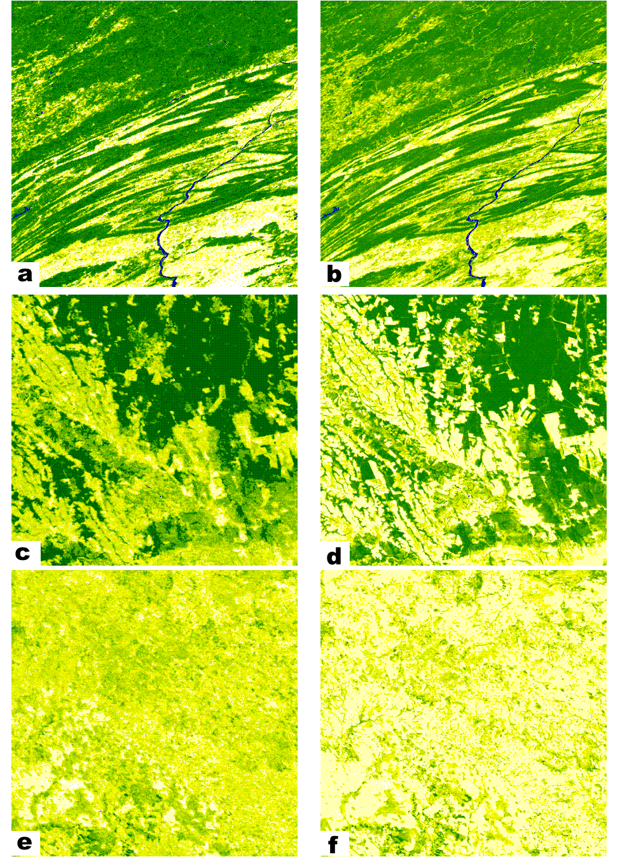
Figure 2 Image pairs showing the Collection 3 500m VCF on the left and the new Collection 5 250m VCF on the right. Darker green color indicates denser tree cover.

Validation
A limited amount of validation has been performed using field data from two sites in Maryland, and three sites in Brazil, South America (Table 2). Initial results show that the new C5 VCF product is substantially more accurate compared to ground based measurements of canopy cover with as much as a 50% improvement in RMSE between the two versions. Although these results are preliminary we are encouraged by the overall improvement in the VCF tree cover product with available ground based validation data.
Site | Field data | Old VCF | New VCF
Maryland
SERC 1 | 29 | 16 | 34
SERC 2 | 48 | 61 | 51
SERC 3 | 33 | 40 | 50
SERC 4 | 59 | 61 | 46
SERC 5 | 69 | 40 | 57
GB 1 | 67 | 74 | 59
GB 2 | 69 | 66 | 68
GB 3 | 33 | 74 | 37
RMSE |  | 19.27% | 9.47%
Mean Absolute Error |  | 14.37% | 7.87%
Mato Grosso
Explorada 1 | 64 |  | 49
Explorada 2 | 80 |  | 78
Moth | 63 |  | 76
Disturbed | 64 |  | 74
Logged 2 | 72 |  | 79
Logged | 55 |  | 79
Ik-log | 50 |  | 80
Tower | 0
RMSE |  |  | 10.46%
Mean Absolute Error |  |  | 9.40%
Table 2 Validation data from field sites in Maryland, United States and Mato Grosso, South America.

Accessing and citing the data
The VCF data are provided free of charge. The data can be accessed from the Land Processes DAAC (https://lpdaac.usgs.gov/lpdaac/products/modis_products_table) under the product name MOD44B in MODIS tile format, and in alternate formats from the Global Land Cover Facility (http://landcover.org). Data should be cited as follows:
Full Citation Example: DiMiceli, C. M., M. L. Carroll, R. A. Sohlberg, C. Huang, M. C. Hansen, and J. R. G. Townshend. "Annual global automated MODIS vegetation continuous fields (MOD44B) at 250 m spatial resolution for data years beginning day 65, 2000–2014, collection 5 percent tree cover, version 6." University of Maryland, College Park, MD, USA (2017).

References
Carroll, M., Townshend, J., Hansen, M., DiMiceli, C., Sohlberg, R., Wurster, K. 2011. Vegetative Cover Conversion and Vegetation Continuous Fields. In Ramachandran,, B., Justice, C.O., Abrams, M. (eds.) Land Remote Sensing and Global Environmental Change: NASA’s Earth Observing System and the Science of ASTER and MODIS Springer-Verlag.
Chang J., Hansen M.C., Pittman K., Carroll M. & DiMiceli C., (2007). Corn and soybean mapping in the united states using MODIS time-series data sets, Agronomy Journal, 99(6):1654-1664.
DeFries, R., Hansen, M., Townshend, J.R.G., Janetos, A.C. and Loveland, T.R. (2000). Continuous Fields 1 Km Tree Cover. College Park, Maryland: The Global Land Cover Facility.
DeFries, R., Field, C. B., Fung, I., Justice, C. O., Matson, P. A., Matthews, M., Mooney, H. A., Potter, C. S., Prentice, K., Sellers, P. J., Townshend, J., Tucker, C. J., Ustin, S. L. and Vitousek, P. M. (1995). Mapping the land surface for global atmosphere-biosphere models: toward continuous distributions of vegetation's functional properties, Journal of Geophysical Research, 100:20,867-20,882.
Hansen, M., Stehman, S, Potapov, P., Loveland, T., Townshend, J., DeFries, R., Pittman, K., Arunarwati, B., Stolle, F., Steininger, M., Carroll, M. and DiMiceli, C. (2008). Humid Tropical Forest Clearing from 2000 to 2005 Quantified Using Multi-temporal and Multi-resolution Remotely Sensed Data, Proceedings National Academy of Sciences, 10, (27), pp. 9439–9444.
Hansen, M., Townshend, J., Stehman, S., Mayaux, P. and Morisette, J. (in preparation). Recommendations on the validation of vegetation continuous fields cover maps. Report from a joint CEOS-WGCV and GOFC-GOLD workshop on validation of vegetation continuous fields products, October 27-28, 2005, Brookings, South Dakota.
Hansen, M., Townshend, J., DeFries, R., and Carroll, M. (2005). Estimation of tree cover using MODIS data at global, continental and regional/local scales. International Journal of Remote Sensing, 26(19):4359-4380.
Hansen, M.C., DeFries, R. S., Townshend, J. R. G., Carroll, M., Dimiceli, C., and Sohlberg, R. A. 2003. Global Percent Tree Cover at a Spatial Resolution of 500 Meters: First results of the MODIS Vegetation Continuous Fields Algorithm. Earth Interactions, 7, 7 – 007.
Hansen, M.C., Sohlberg, R., Dimiceli, C., Carroll, M., DeFries, R.S. and Townshend, J.R.G. (2002). Towards an operational MODIS continuous field of percent tree cover algorithm: Examples using AVHRR and MODIS data. Remote Sensing of Environment, 83(1-2): 303-319.
Hansen, M. C., DeFries, R.S., Townshend, J.R.G., and Sohlberg, R. (2000). Global land cover classification at 1km spatial resolution using a classification tree approach, International Journal of Remote Sensing, 21, 1331-1364.
Olson, D.M., Dinerstein, E., Wikramanayake, E.D., Burgess, N.D., Powell, G.V.N., Underwood, E.C., D'Amico, J.A., Itoua, I., Strand, H.E., Morrison, J.C., Loucks, C.J., Allnutt, T.F., Ricketts, T.H., Kura, Y., Lamoreux, J.F., Wettengel, W.W., Hedao, P. and Kassem, K.R. (2001). Terrestrial Ecoregions of the World: A New Map of Life on Earth. BioScience, 51(11): 933-938.
Townshend, J.R.G. and Justice, C.O. 1990. The spatial variation of vegetation at very large scales. International Journal of Remote Sensing, 11, 149-157.

